Name____________________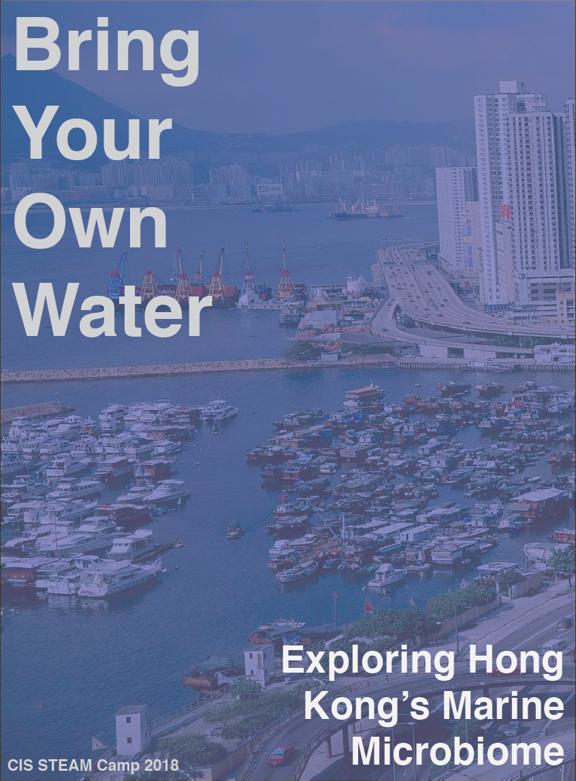

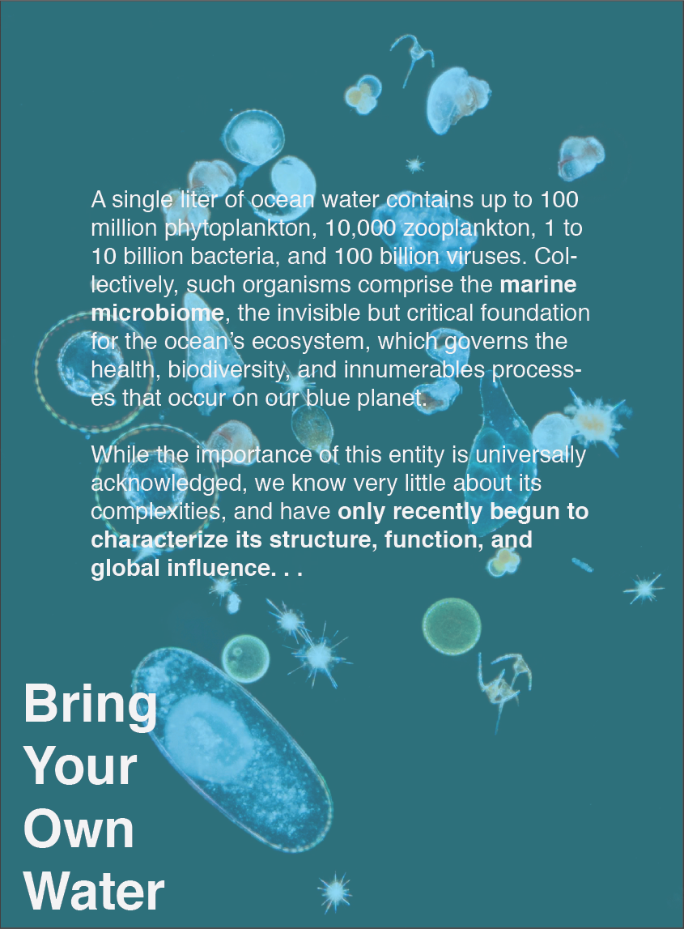

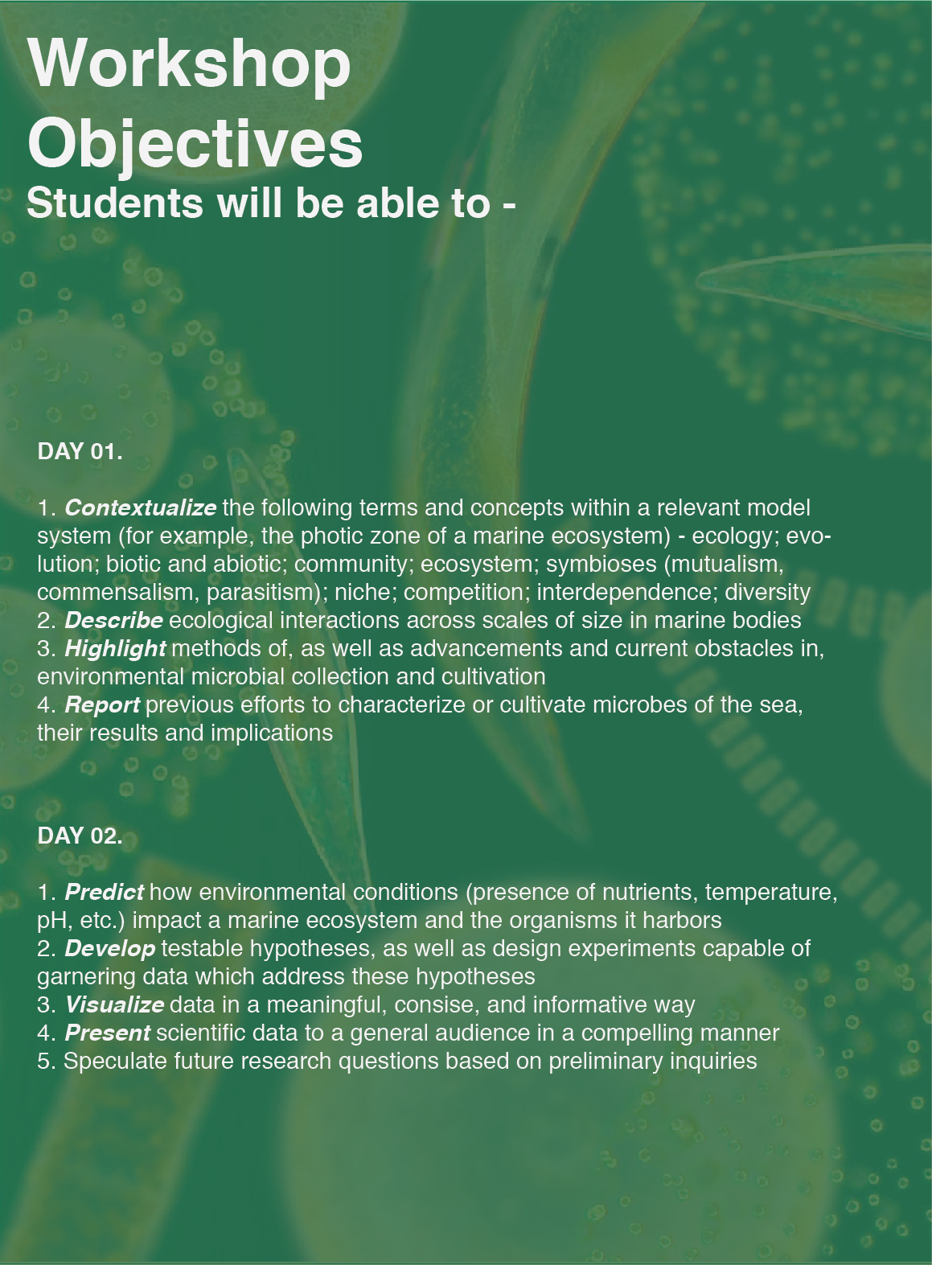

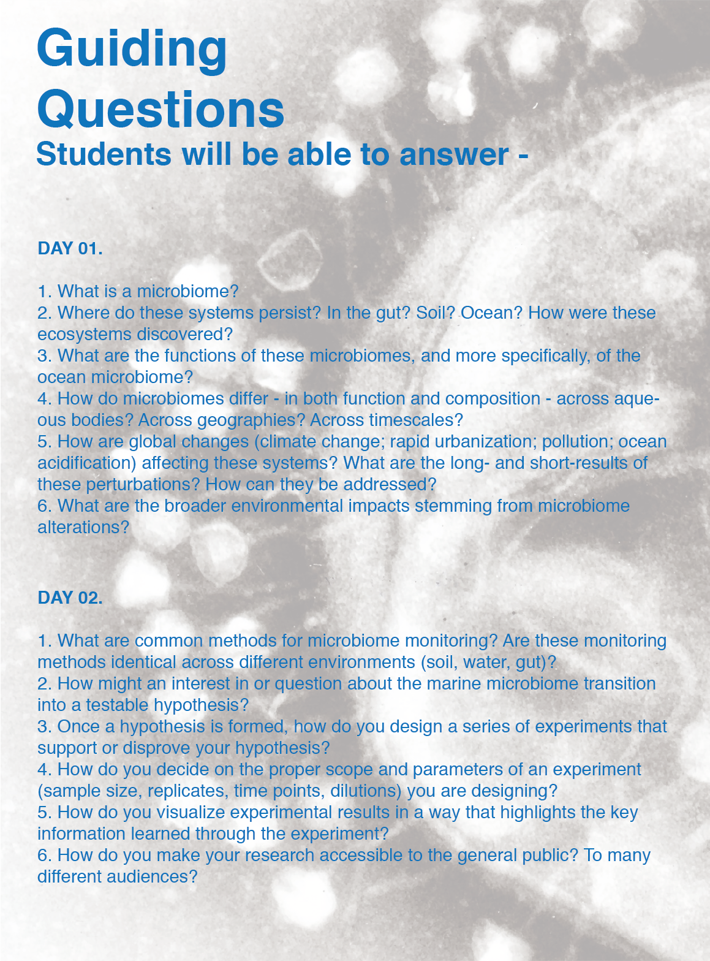

***Bring Your Own Water* : Exploring Hong Kong’s Ocean Microbiome - Teacher’s Guide**

Prepared by Avery Normandin, Ashton Strait, and Devora Najjar, 2018.

*Children’s textbooks, from science to history, show no nearby scenes, suggest or demand no firsthand knowing, just formulas and far-off people and places, as if numbers and language had no local meaning, as if their present had no past, no future, the student a vessel not an actor.*

Anne Whiston Spirn

*The Language of Landscape*

1998

**Required Materials.**

50 note cards containing organisms/descriptions for the interactive scales exercise

100 syringe filters: 50 each size, for filtering macroscopic vs. microscopic organisms

50 petri dishes for Daphnia culture

10 sets of clear well plates for Daphnia visualization

5 hot plates for Daphnia culture

pH strips for testing water samples

60 pre-made agar plates for bioart

60 pre-made agar plates for culturing own samples

6-10 light microscopes (low power) for visualizing Daphnia and other macroscopic organisms

Caffeine powder for Daphnia experiments

100 pasteur pipets for making dilutions and transferring samples

Assorted glassware for mixing and pouring samples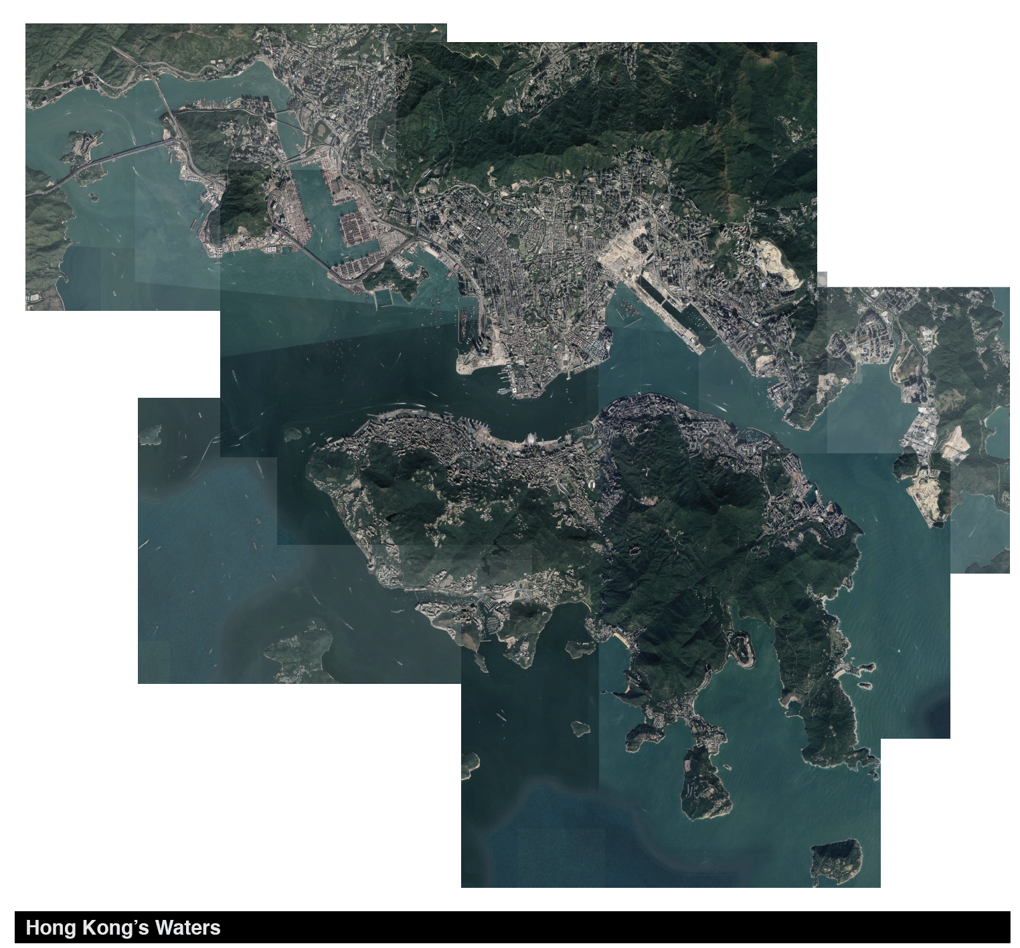

**Day I. *Interactions Across Scales in Marine Ecosystems*.**

This guide will provide instructors with the necessary information to run Day I of the ‘*Bring Your Own Water’* workshop. While the overall goal of the workshop is to provide students with hands-on understanding of aquatic, and in particular marine, microbiomes, Day I will additionally provide a primer on foundational concepts of ecology, marine ecosystems, and outstanding questions relevant to the field.

*Instructors using this guide are assumed to have familiarity with basic biology and environmental science.*

**Introduction to Class (10 minutes)**

*Allow students to find their seats and go around the class for names and an ice breaker*

**Introductory Discussion. *Introduction to Ecology and Marine Ecosystems* (25 minutes).**

*The introductory discussion should last for 25 minutes.*

Begin by asking students, ***what*** *is ecology?* ***Where*** *is ecology? What is your relationship, your* ***connection****, with ecology?*

Make note of various definitions, observations, and keywords on the board; what conclusions can you, the facilitator, instructor, draw? Synthesize and reflect with the class: Is a certain ***scale*** implied by students’ answers? For example, is the common notion of “ecology” restricted to what is visible with the naked eye? Who are the *actors* in an **ecosystem** - the living, the nonliving? - and how do they interact? Are they friends? Foes? Perhaps neither?

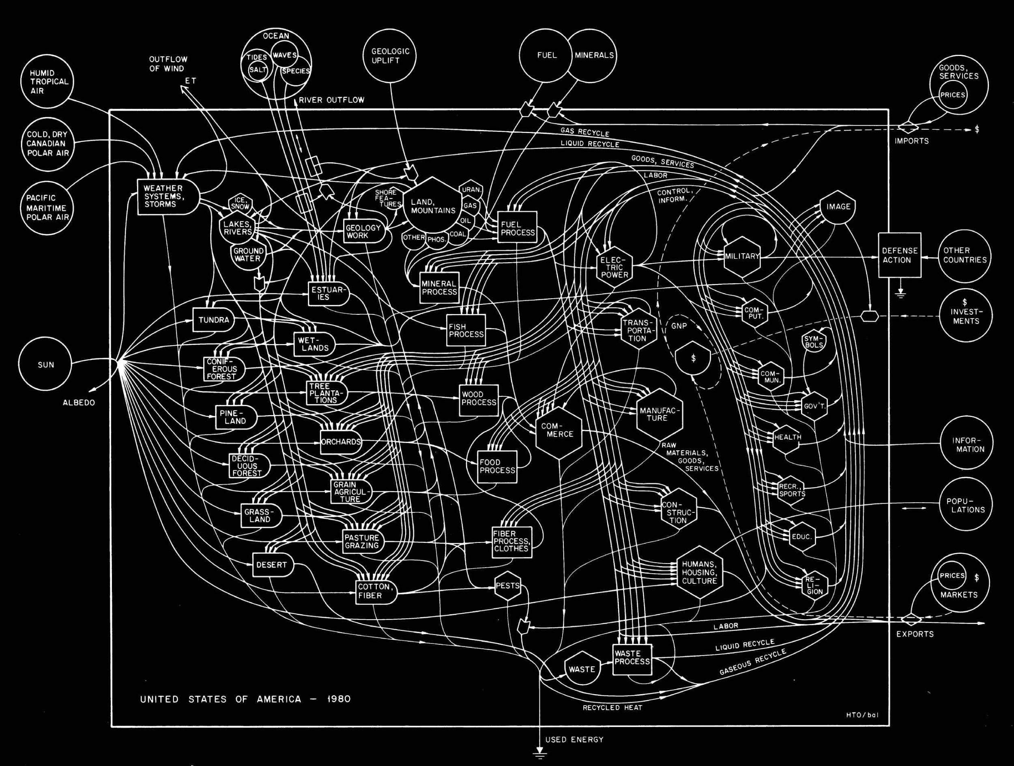

Proceed to introduce how you will use the term throughout the workshop:

Ecology is defined in two ways. First, most simply, it is the study of **interactions**: both how living, **or biotic**, things (organisms) interact with one another, and / or with their **abiotic**, or nonliving, environment.

Second, it is the study that assesses the **transformation, or transfer of, energy between systems**. A “system” could be a single living thing - a whale, a bacterium -, or the whole-Earth itself. Two ways to frame these definitions include one likely familiar diagram - [a marine food web](http://ec.europa.eu/environment/marine/good-environmental-status/descriptor-4/index_en.htm) - and perhaps lesser known one - an ecologist called Howard T. Odum’s analysis of the US economy (above). After a brief analysis of each graphic, ask students, *what* ***types of interactions*** *occur in each example? At what points is* ***energy, currency being transferred****, and* ***how****? What, exactly, is the* ***energy*** *being transferred? And how do the representations of ecology differ? What is the role of humans, their processes, in each, if any?*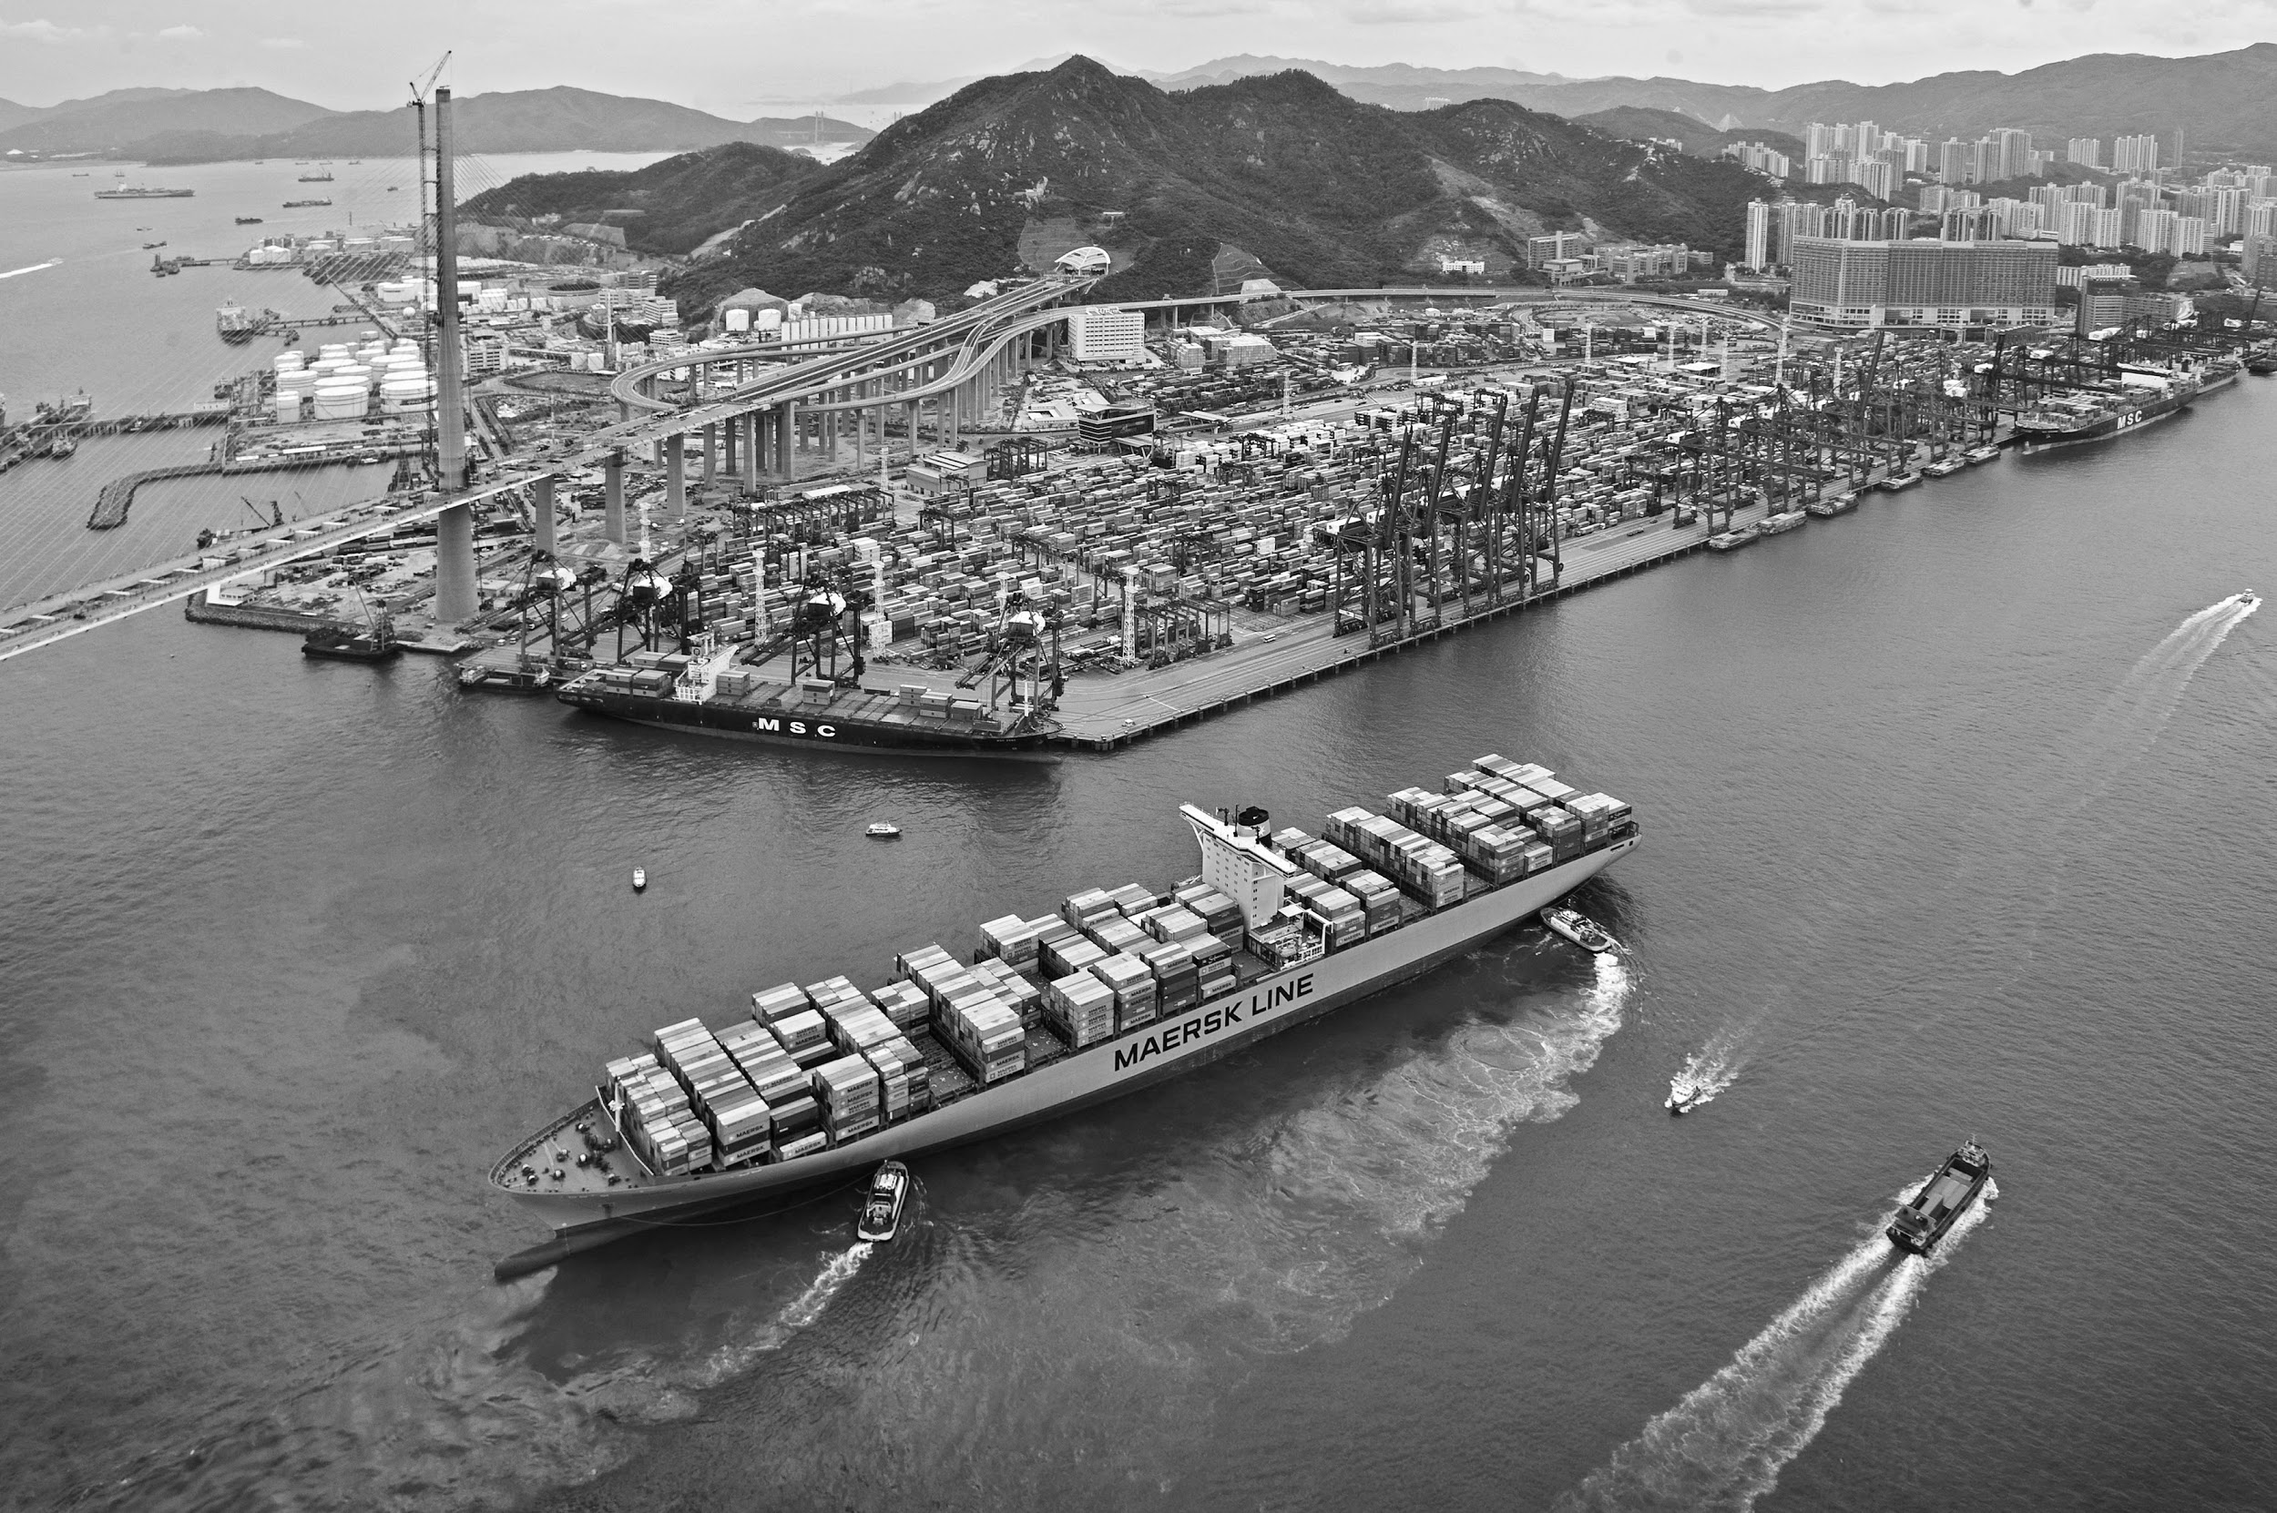

Proceed to discuss the ecology of a familiar location - the **Port of Hong Kong.** Describe to students that, historically, nature - or what is “natural” - has been considered the antithesis of the city; the industrial; the manmade. With a careful eye, though, life, and elements of nature - its governing forces - are pervasive in developed territories. Explain to students that, in fact, their city, their home, is full of life - affected by their actions and behaviors - worthy of exploration and discovery. The goal of this workshop is to inspire students to take action in characterizing their city through scientific inquiry, driven by curiosity and passion.

Given the image of a perhaps-familiar port (above), what do students observe? What is natural, undisturbed? What is developed, synthetic? How do these two interact?

Hone in on what students know or suspect is present in the water. Have they observed any particular plant or animal species there? Sessile organisms fixed to support structures on the shore? Algae unwelcomingly decorating the hull of a ship? Seabirds eagerly awaiting the arrival of an unsuspecting fish?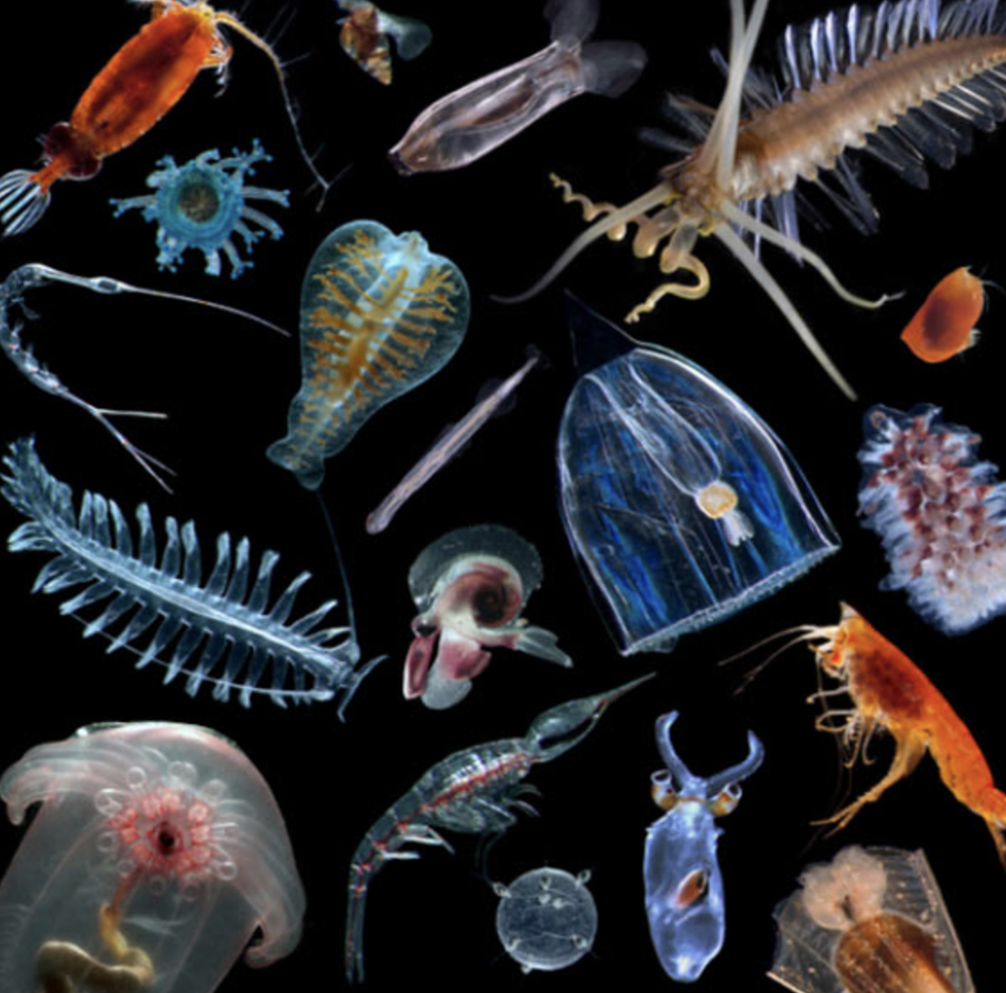

If a student mentions any sort of microbe - a bacterium, a virus, or plankton, for example - inquire more about this answer (*How* ***many*** *microbes are there? What is their* ***size relative to other organisms in the environment****?*). Or, if a student did not mention microbes as a potential Port inhabitant, introduce the idea.

Proceed to illustrate that the Port of Hong Kong, in fact, harbors billions of invisible wondrous, alien-like creatures - micro-organisms, or microbes.

Microbes can be found in many different places - not just the **ocean**, but also in the **soil**, and even **inside you.** A group of different types of microbes living together, interacting, is called a **microbiome. Microbiomes** play important roles in the environment and in your own health. Ask students if they can point out any roles of any of these microbiomes. Are their activities tangible? Do the behaviors, the ecology, of microbes directly affect students? How?

By far, the most massive and potent of these microbiomes is that thriving in the ocean. The ocean microbiome dominates 71% of the Earth’s surface, orchestrating virtually all of its major elemental cycles (that is, biogeochemical cycles - carbon, oxygen, nitrogen, sulfur, phosphorus, and water).

*Proceed with in interactive lesson to hone in on some specific characters we might find in the ocean microbiome, and how they affect interactions with larger-scale organisms.*

**Interactive Lesson. *The Ocean Across Scales* (20 minutes).**

Following the introductory presentation, students will explore the ocean **across scales** in an interactive lesson:

In this exercise, a pair of students will be given a card with a picture (or microscope image) of an organism, containing the name and a brief description. The whole group will work together to order these organisms by size from smallest (bacteriophage) to largest (blue whale) in a line they can generally agree on, placing cards together if they are unsure of the order in certain parts of the timeline. We will poll the class to see if anyone disagrees with any incorrect or ambiguous placements and ask students who have the right answer to explain their reasoning and move the card. Together, we will move around cards until we get the right order and have discussed any organisms with which students are unfamiliar.

We will introduce more organisms after students have completed the size exercise, to give students a chance to further cement some intuition about the relative sizes of organisms in the ocean. This activity will include a brief discussion of mutualistic relationships between macroscopic and microscopic organisms, such as the Hawaiian bobtail squid (*Euprymna scolopes*) and *Vibrio fischeri*, a bacterium that colonizes in the light organs of the squid and contribute to its sophisticated camouflage abilities.

We will also build on the introduction to refine concepts such as relative lifespans of different organisms, eukaryotic vs. prokaryotic organisms, and whether viruses are truly “living.”

We will briefly discuss visual and graphical representations of data, with an emphasis on orders of magnitude and the usefulness of log scales for data representation.

**Break for 10 minutes.**

**Activity 1. Cultivating Microorganisms from Hong Kong Ocean Water (25 minutes).**

Students will filter ocean water samples (their own or provided by instructors) and plate a selection of the water on two types of plates: marine broth plates, on which most marine bacteria should be able to grow; and Vibrio-selective plates, which will only allow bacteria from the genus Vibrio (or those closely related) to grow. Plates will grow overnight at room temperature and cultures will be visible within 24 hours.

flesh out specific learning outcomes for this activity. What do the plates contain? Do you think that we are able to culture ALL ocean/aquatic microbes? Why or why not?

Do students predict that their plates will yield different results, depending on the water sample (location)? Why or why not? Additionally, would having the plates under different growing conditions impact how the plate looks? Why?

**Activity 2.Making bio-art with *Vibrio fischeri* (25 minutes).**

Students will make their own designs with the luminescent bacteria *V. fischeri*. Students will use bacteria to draw on agar plates, and their designs will blossom overnight and be visible the next day.

**Demonstration. Detecting the Activity of Marine Bacteriophages.**

Instructors will demonstrate a plaque assay for students, as a way of visualizing the most abundant microorganisms in the ocean, bacteriophages. This exercise will reinforce phages’ important role in ocean microbiomes. Instructors will use ocean water samples collected by themselves and students to perform simple plaque assays on specific bacterial strains, which will be visualizable as “plaques” (empty spots) on a bacterial culture the next day.

**Day II. *Environmental Impacts on Aquatic Microbes.***

**Recap of day 1:** ***Review Key Concepts in the Marine Ecosystem/Microbiome* (15 minutes).**

Students will have the ability to observe the plated and filtered water that was done the day before and have the chance to document their work. The students should be encouraged to view each other’s results and attempt to explain what is present on the plates.

Additionally, teachers are encouraged to review the key vocabulary taught the day before to make sure that students are still familiar with the concepts and their context.

The key vocabulary words are: ecology; evolution; biotic and abiotic; community; ecosystem; symbioses (mutualism, commensalism, parasitism); niche; competition; interdependence; diversity.

These vocabulary words should be contextualized within the context of the Hong Kong marine microbiome, and teachers should encourage the use of the highlighted vocabulary words as appropriate when discussing the results of the filtering and phage experiments.

**Interactive Lesson. *The role of macroscopic particles in aquatic environments.* (15 mins)*.***

Instructors will discuss the role of macroscopic particles and organisms in ocean and freshwater ecosystems. Macroscopic ocean particles to note are marine snow and fecal pellets. Multicellular organisms to note include algae as a facilitator in the aggregation of bacterial communities, copepods allowing for proper nutrient cycling in the ocean ecosystem.

This lesson will also include specific examples of human effects on aquatic ecosystems. Important points to highlight are the pollutants that residents are putting into their water sources as well as industrial run-off that have affected streams and oceans (e.g. chemicals, microplastics).

**Activity 1. *Visualizing particles from water samples* (25 mins)*.***

*Learning objectives*: students will learn about the small scale factors and organisms present in the water in their own local environments, and gain an appreciation for their importance in ecosystems.

Students will filter their water samples with a larger filter than used the previous day, in order to collect particulate matter and any multicellular organisms. Students will then rinse the filters and elute from the filter and plate on a microscope slide to view what was collected under a microscope.

**Scratch integration:** Used USB webcams can be made into “hacked” microscopes for observation of Daphnia conditions in real time. These “microscopes” have an extension within congimates in which students can work in groups to develop programs which respond to the live webcam feed, including games or stories.

Students will record results through imaging (photograph or drawing) as well as accompanying descriptive text.

Questions to ask students include:

Do the materials eluted look different from what was eluted with a smaller filter?

Are there were any particularly interesting or surprising things seen?

Are there any unknown macroscopic items that were seen?

How does your sample differ from others?

How do these results change how you think about the ocean?

**<break for 5-10 minutes>**

**Lesson 2. *Bioindicators* (15 mins).**

After allowing students to visualize macroscopic particles and organisms, the idea of biomonitoring will be introduced. Biomonitoring is the practice of using living organisms to to understand changes within an environment, in this case the ocean. A “bioindicator” species is a type of biomonitor. These are organisms which respond to changes in the environment in a measurable way, which can be used to evaluate the health of the environment. 

Some characteristics of a good bioindicator include a short reproductive cycle that can quickly reflect environmental changes [2] relatively immobile [3] sensitive to a wide range of environmental stressors [4] able to survive high levels of pollutants [5] easy to use for lab experiments (Le, Quynh-Anh Vu, et al. "Daphnia in water quality biomonitoring-“omic” approaches." *Toxicology and Environmental Health Sciences* 8.1 (2016): 1-6.) 

The bioindicator that will be used is the microcrustaceans *Daphnia pulex*, which holds responds to many abiotic environmental factors, such as metals, or titanium dioxide, a common ingredient in sunscreen. The impact of these environmental factors can be seen in through the decreased growth rate of the *daphnia*, which can be measured over time.

**Activity 2.*****Daphnia Response to Stimuli* (25 mins).**

*Learning objectives*: students will get an introduction to key processes and organisms occurring one step above the scale of bacteria in the ocean biome, and how humans have affected organisms and ecosystems at this scale.

We will have students measure a response that can be seen in real time: heart rate, which can be measured by looking at single animals under a light microscope. We will then add one or more of the following abiotic factors to the Daphnia’s liquid: caffeine, ethanol, or temperature. We will take caffeine as our example: students will work in small groups to 1) formulate a hypothesis about the effect of caffeine on Daphnia 2) apply some knowledge from the scales exercise to calculate the relative size difference between humans and Daphnia in order to 3) decide how much caffeine to add and in what increments. Students will then measure and record the change in heart rate of the Daphnia samples upon adding different amounts of caffeine. We will graph these data points individually and all together for students to see and discuss whether the results confirm or refute their hypotheses. We will use the graphs of individual vs. combined data points as starting points to briefly discuss the effects that sample size can have on the quality of data collected and reproducibility of experiments.

Students will be invited to use their own water (post-filtration) to try to culture Daphnia. We can provide ideas for students to test the quality of the water they collected for pH and other factors, and ways to measure population growth rate.